Internet Of Things: Watering Plants

# What is IoT?

The **Internet of things** (**IoT**) is the extension of [Internet](https://en.wikipedia.org/wiki/Internet) connectivity into physical devices and everyday objects. Embedded with [electronics](https://en.wikipedia.org/wiki/Electronics), [Internet connectivity](https://en.wikipedia.org/wiki/Internet_access), and other forms of hardware (such as [sensors](https://en.wikipedia.org/wiki/Sensor)), these devices can communicate and interact with others over the Internet, and they can be remotely monitored and controller.

# What is this project about?

This project revolves around the concepts of IoT and all the things I have learnt at this place, Maker’s Asylum. Automatic Plant Watering System is a kind of an embedded system which will be controlled from a smart device like a phone or a laptop using a web service and an Android app (for the smartphone) to plant waters from a remote place. This project lays the foundation for IoT based applications to automate the housing system. This is the first step to a larger goal.

# Materials, Tools and Softwares required

# Steps undertaken:

## Step 1: Getting comfortable with NodeMCU

NodeMCU is an open source IoT platform. It is one of the most feasible micro-controllers to work with. It uses the same Arduino IDE and it is easy to work with. In order to get comfortable with it, I started by interfacing a web browser with the microcontroller. Firstly, sending messages from NodeMCU to the browser and vice versa. Secondly, there were two ways to set-up WiFi which I explored.

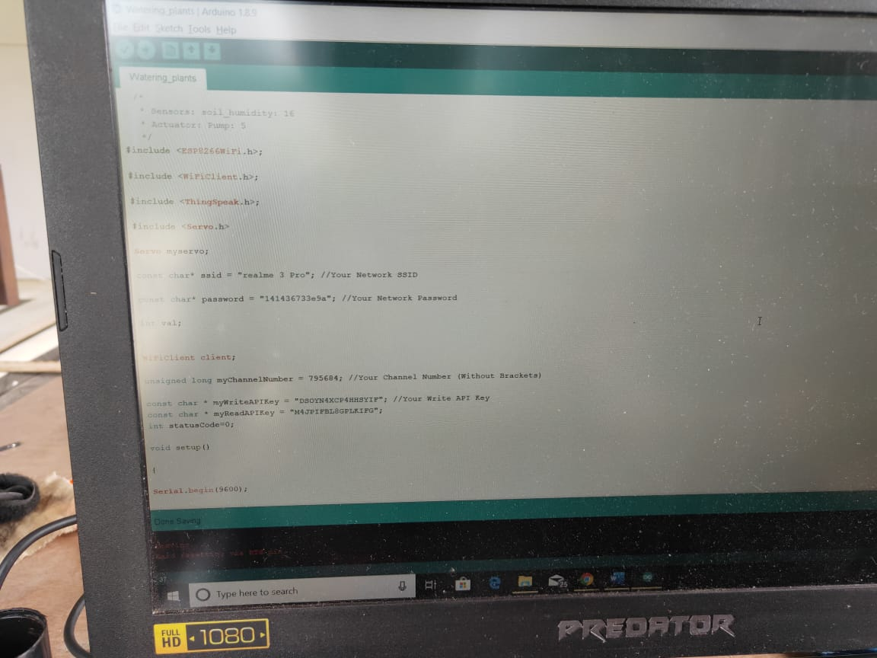

## Step 2: Using an Online Service for IoT

After getting comfortable with NodeMCU, the other task was to set a web service which allows to exchange data from a smart device to the microcontroller. For this purpose, I made use of ThingSpeak which is an open source web service. The interaction required me to make a Script on Arduino IDE and upload it to NodeMCU. The data was seen to be displayed on the website.

## Step 3: Create IoT Automatic Watering System App

In order to not make this step complicated and easy to understand I had to use MIT app inventer. The interface is user friendly and allows you to design and create your app, which is easy to learn. This step was fun as things got way too easy for me.

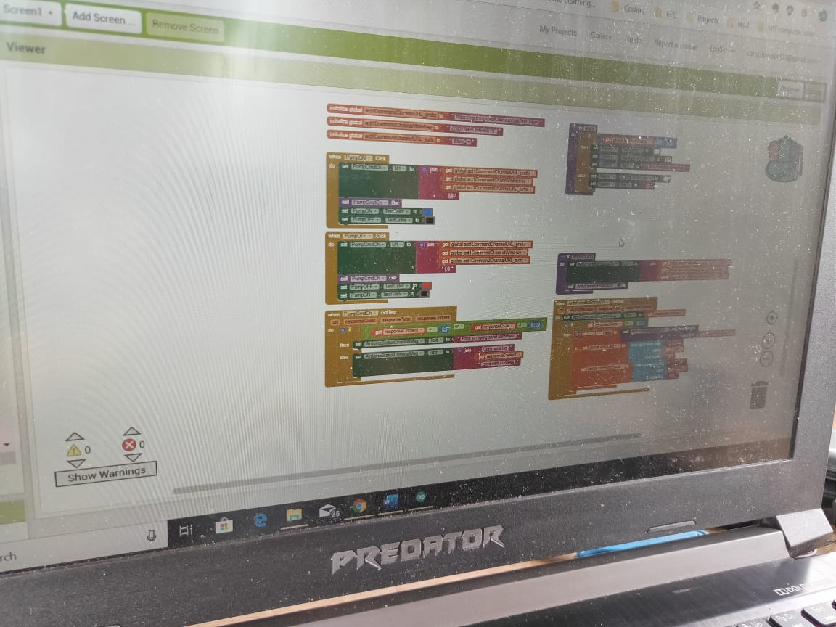

## 

## Step 4: Interfacing the app with ThingSpeak

Here I just had to take the Read API key and Write API key from the channel created on ThingSpeak and paste it in the Block Diagram of the app. This step will be much more clear once you follow the above ones in a sequential order.

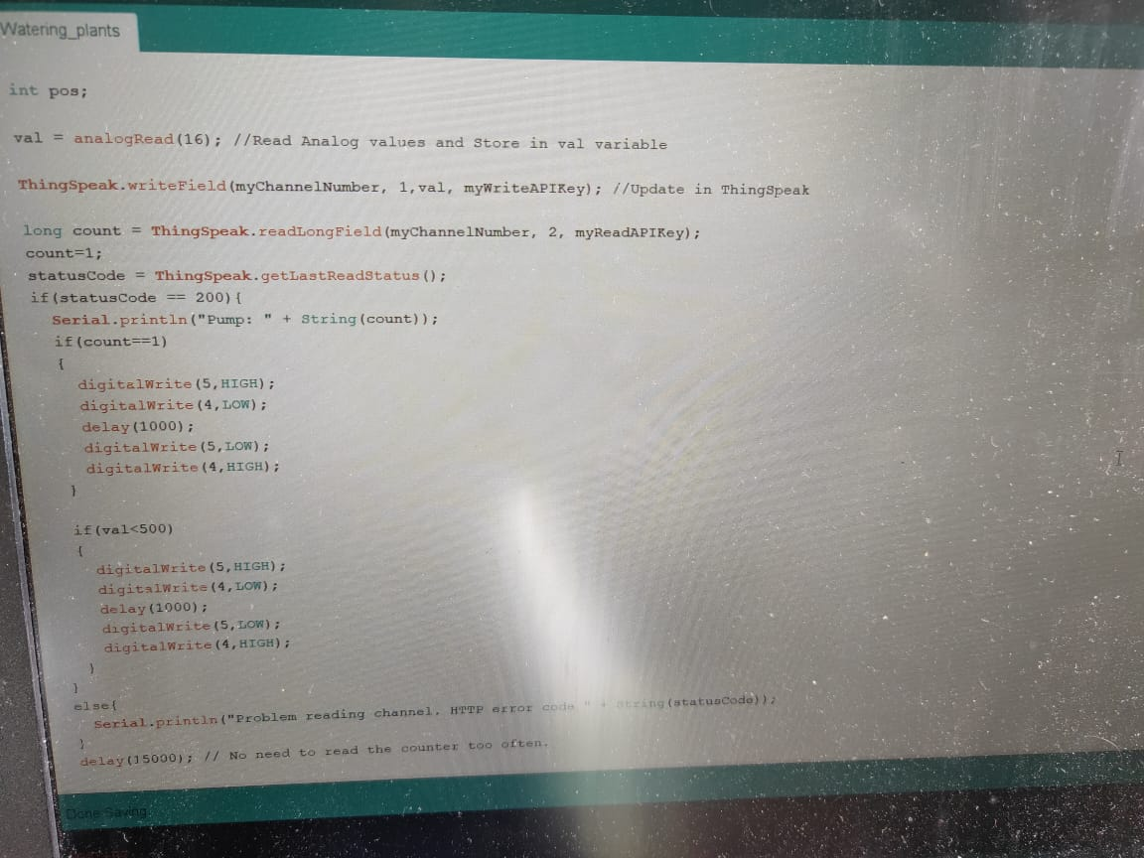

## Step 5: Testing the whole software part

After setting up the entire interfacing of the NodeMCU and the App, it was time to see whether the request sent to the NodeMCU is actually responding or not. This thing was tested a couple of times and some modifications made the process quite smooth. The software interfacing was a success and we could now set the hardware in place.

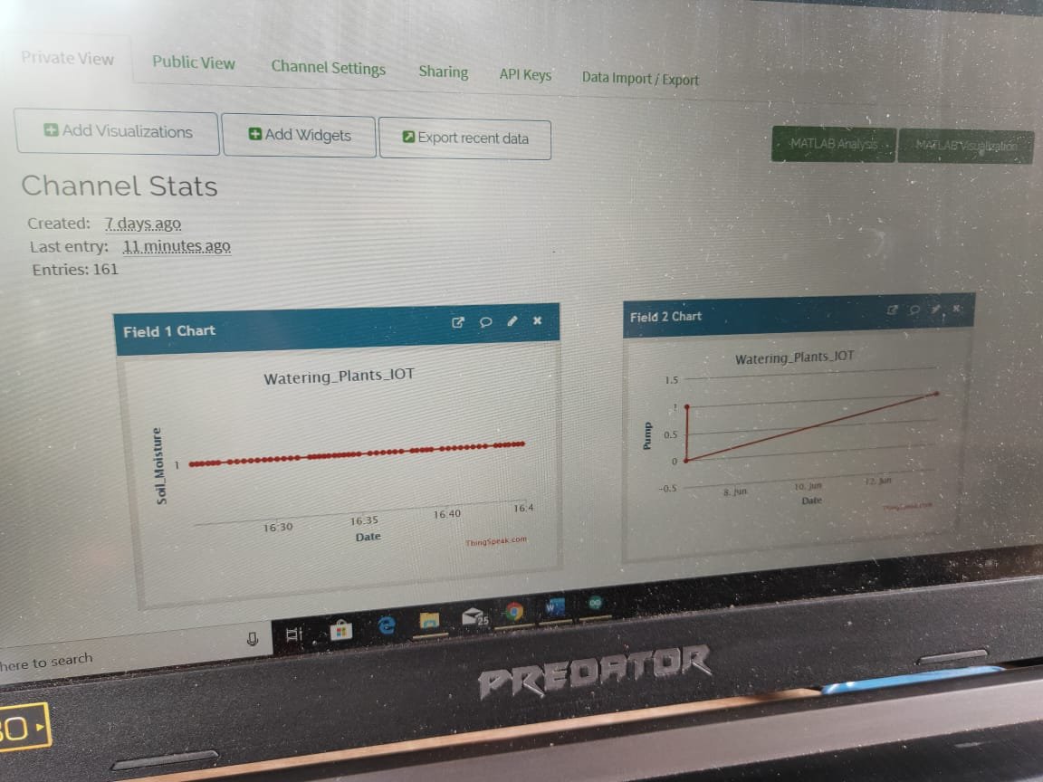

## Step 6: Setting up the circuitry

Setting up the circuitry is the most fun and easiest part of the project. You have the excitement to finally display what you have been working on. The circuitry is to be set up on the breadboard

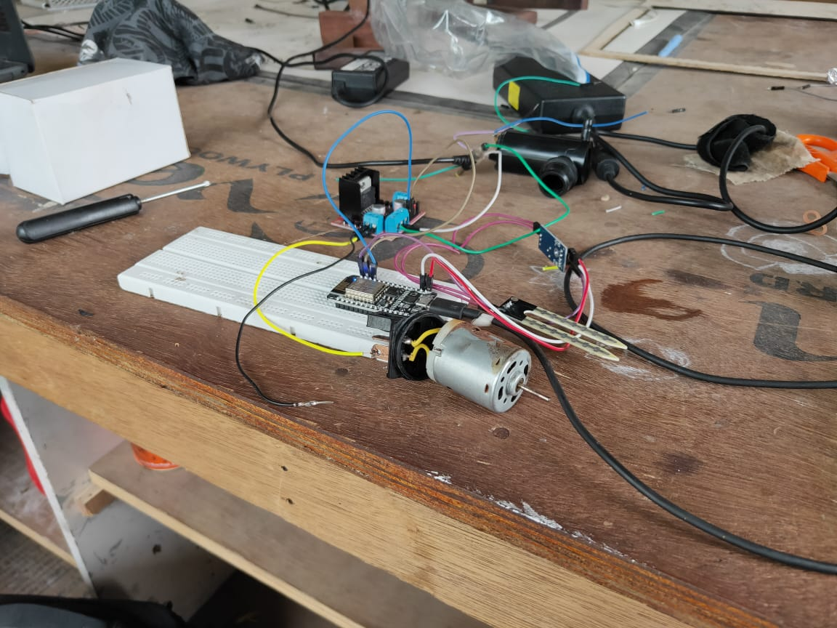

# The Learning Experience

Learning about IoT was fun. It taught me how to interface and use various softwares. I learnt a lot about electronics, it was like turning a blind eye to the end of the tunnel. The end result gave me a lot of joy. It was a product which I made individually and it was useful and can be used in the workshop. I look forward to explore this field further as this project has given me deeper insights into the potential of IoT.